Social Media Post 1

Did you know?
Personal development is the leading reason individuals join direct selling according
to @[TAG DSEF]. What motivated you to join [YOUR COMPANY]?
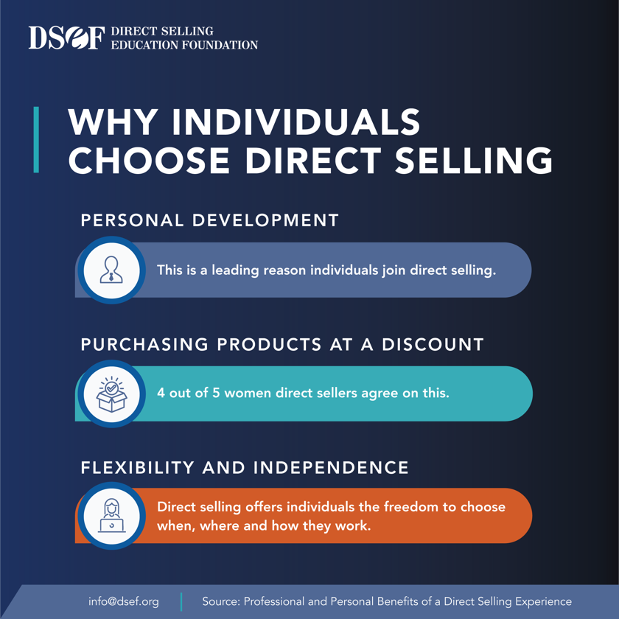
We’d love to hear in the comments!

