Social Media Post 4

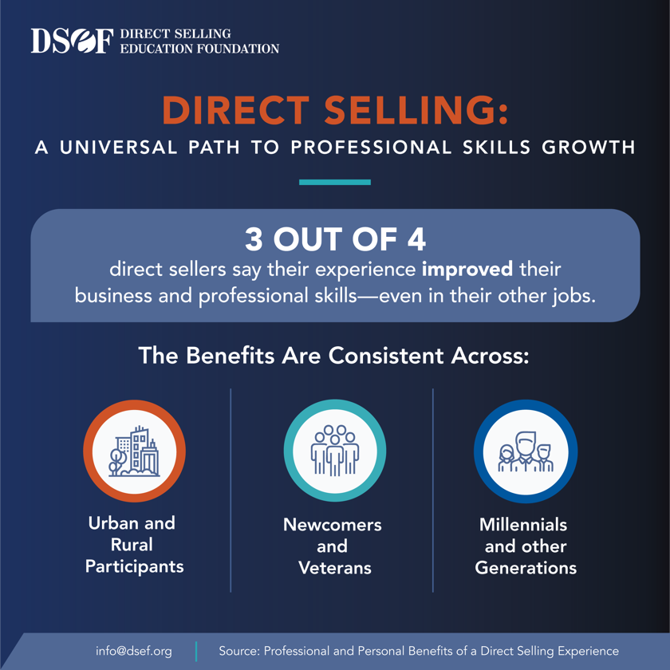
Grateful to be part of a channel that not only builds businesses but also develops essential life skills!

