Social Media Post 3

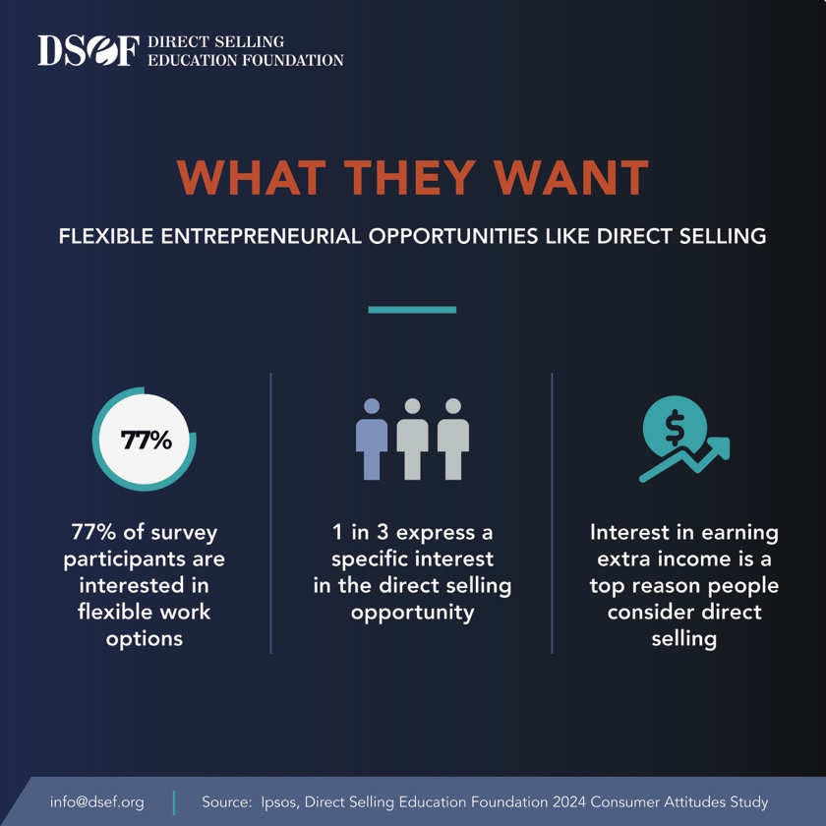
Direct selling delivers. The top attributes important to potential entrepreneurs are the very heart of the opportunity we offer: earning extra income, flexible schedules, low start-up costs and partnering with a trustworthy brand.

