Social Media Post 4

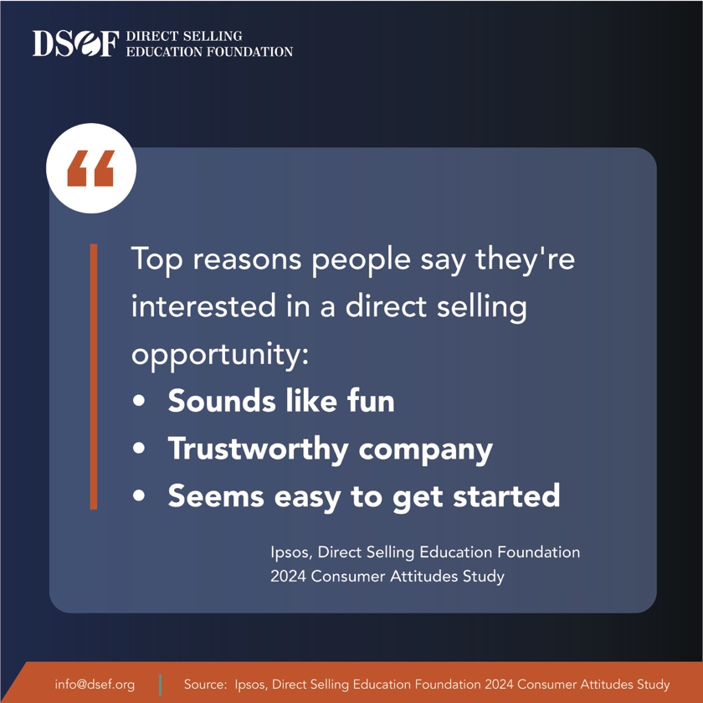
Proud to be a part of our company. Direct selling delivers a flexible entrepreneurial opportunity.

